**INDUSTRIAL TRAINING REPORT**

**TYPING SPEED CALCULATOR**

Submitted in partial fulfillment of the

Requirements for the award of

**Degree of Bachelor of Technology in Computer Science Engineering**



Submitted By

Name: DANISH KHAN

University Roll No. 1814310071

**SUBMITTED TO:**

**Department of Computer Science & Engineering**

IMS Engineering college

GHAZIABAD (UP).

**DECLARATION**

I hereby declare that the Industrial Training Report entitled (" Typing Speed Calculator ") is an authentic record of my own work as requirements of Industrial Training during the period from 15.06.2020 to 25.09.2020 for the award of degree of B.Tech. (Computer Science & Engineering), IMS ENGINEERING COLLEGE, GZB , under the guidance of Mr. Hakim Singh

**(Signature of student)**

**(ROLL NO - 1814310071)**

**Date: ____________________**

**Head of Department**

**(Signature and Seal)**

**ACKNOWLEDGEMENT**

An endeavor is not complete and successful till the people who make it possible are given due credit for making it possible. I take this opportunity to thank all those who have made the endeavor of mine successful for me and for all.

I take the opportunity to express my gratitude to all of them who in some or the other way helped me to accomplish this project. The study cannot be completed without their guidance, assistance ,inspiration and co-operation.

I would like to express my deep sense of gratitude to my respected project guide Mr. Hakim Singh for his support & cooperation.

Secondly I would like to thank my close friends &well wishers who were there for me whenever required.

Last but not the least WWW which provided with all the required data & information.

**About Company/Industry/Institute**

**Coursera** is an American [massive open online course](https://en.wikipedia.org/wiki/Massive_open_online_course) (MOOC) provider founded in 2012 by [Stanford University](https://en.wikipedia.org/wiki/Stanford_University)'s computer science professors [Andrew Ng](https://en.wikipedia.org/wiki/Andrew_Ng) and [Daphne Koller](https://en.wikipedia.org/wiki/Daphne_Koller) that offers [massive open online courses](https://en.wikipedia.org/wiki/Massive_open_online_courses) (MOOC), specializations, degrees, professional and mastertrack courses.

Coursera works with universities and other organizations to offer online courses, certifications, and degrees in a variety of subjects.

Coursera courses last approximately four to twelve weeks, with one to two hours of video lectures a week. These courses provide quizzes, weekly exercises, peer-graded and reviewed assignments, an optional Honors assignment and sometimes a final project or exam to complete the course. Courses are also provided on-demand, in which case users can take their time in completing the course with all of the material available at once. As of May 2015, Coursera offered 104 on-demand courses it also provides guided projects which are short 2-3 hour projects that can be done.

As of 2017, Coursera offers full master's degrees. They first started with Master's in Innovation and Entrepreneurship (OMIE) from [HEC Paris](https://en.wikipedia.org/wiki/HEC_Paris) and Master's of Accounting (iMSA) from the [University of Illinois](https://en.wikipedia.org/wiki/University_of_Illinois), but have moved on to offer Master of Computer Science in Data Science and Master of Business Administration (iMBA), both from University of Illinois. Also as part of MBA; there are some courses are offered separately and will be included in the curriculum of MBA when being enrolled in like digital marketing courses.

In 2020, in response to the [COVID-19 pandemic](https://en.wikipedia.org/wiki/COVID-19_pandemic), Coursera launched a course by the [Jameel Institute](https://en.wikipedia.org/wiki/Jameel_Institute) at [Imperial College London](https://en.wikipedia.org/wiki/Imperial_College_London). Called "[Science Matters: Let's Talk About COVID-19](https://www.coursera.org/learn/covid-19)", the course was the most popular launched on Coursera in 2020, with over 130,000 enrolled learners that year.  The course was presented by Jameel Institute research lead Professor [Helen Ward](https://en.wikipedia.org/wiki/Helen_Ward_(scientist)) and deputy director Dr Katharina Hauck, with specific modules in collaboration with other researchers from across Imperial

**CERTIFICATESTABLE OF CONTENTS**

1. **PROBLEMS IN DAILY LIFE**
2. **INTRODUCTION**
3. **WORKING DIAGRAM**
4. **LANGUAGE USED**
5. **FEATURES**
6. **BARRIERS**
7. **WORKING**

**PROBLEMS IN DAILY LIFE**

Many times its happens that even a good student who is intelligent as well as knowledgeable do not have good typing speed which makes him less capable as compared to another student as a result student cannot produce the desired output in less time therefore there is a need for typing speed calculator which calculates the actual speed of the writer and makes his speed good as BIG Industry Level Employ have

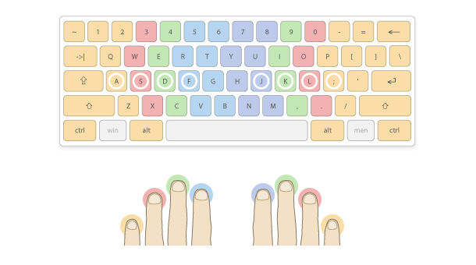

**INTRODUCTION**

The idea behind the project is to check the speed of the writer so that the writer can be able to check the speed of his typing and can improve it because in the industry level so you should have good typing speed as a result you can produce more output than others



**WORKING DIAGRAM**

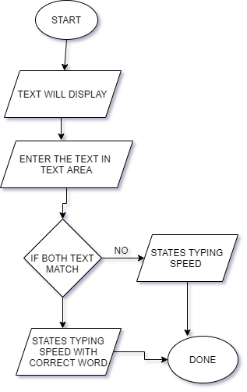

**LANGUAGE USED**

* **HTML**
* **CSS**
* **BOOTSTRAP**
* **JAVASCRIPT**

**FEATURES**

* **It will display the time taken by the user to type**
* **It will display the correct word out of total word that the user typed**
* **It will display the total words that the user have typed**
* **It will display the typing speed of the user**

**BARRIERS**

There are some problems that I face while making this project.

* Which MODULE should be imported to perform a particular task
* How to install a MODULE
* How to Clean Data of previously made QR

* How to Decrease Time complexity and space complexity

**WORKING**

**Step 1 :- Click on the Start Button**

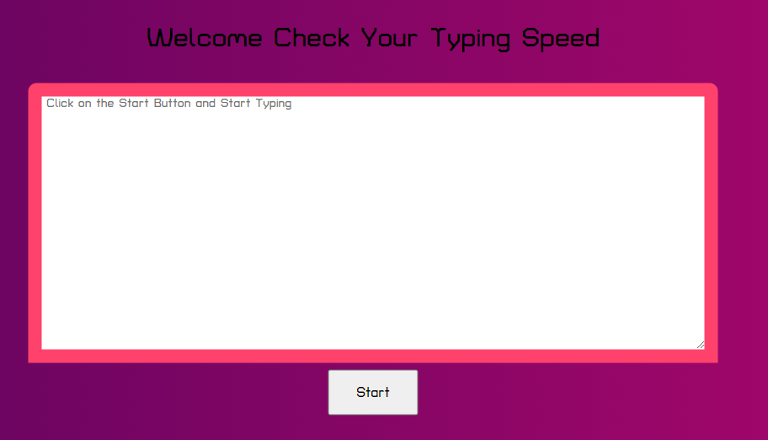

**WORKING**

**Step 2 :- Start typing the Text**

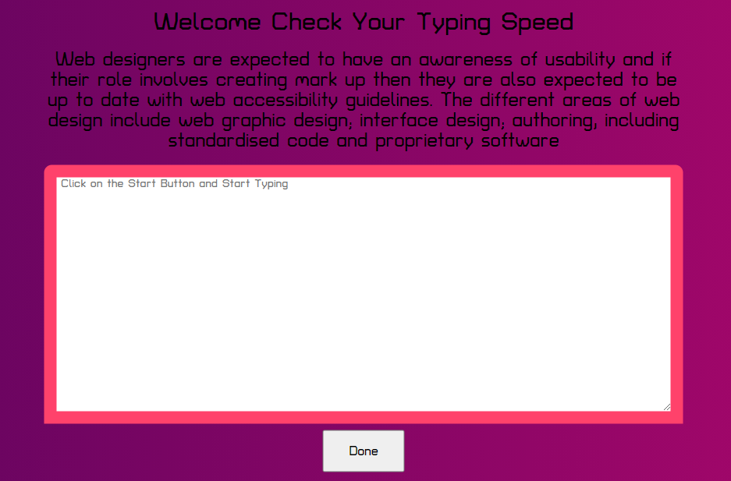

**WORKING**

**Step 3 :- After typing the text click on the Done Button**

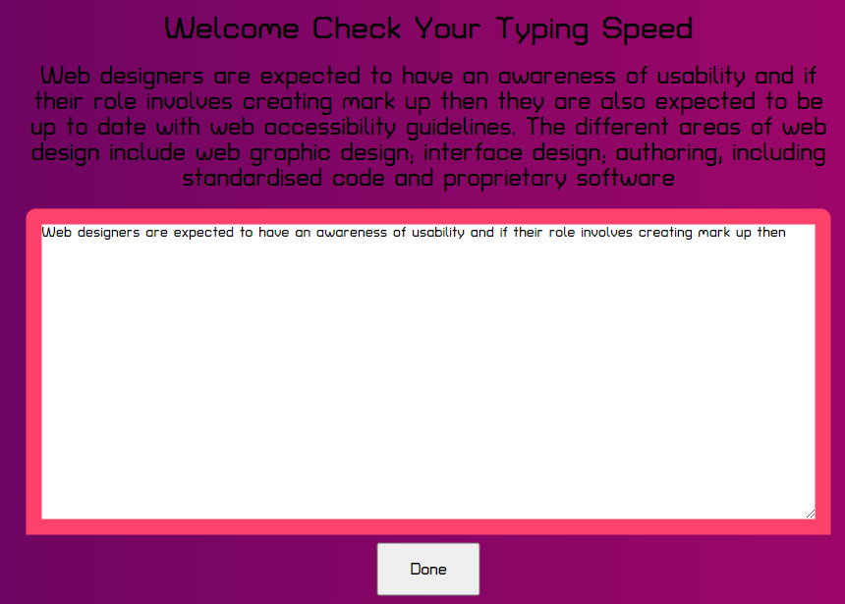

**WORKING**

**Step 4 :- User will get all the information regarding typing speed**

